Utah State Hospital
Forgotten Patients Cemetery Project

“There is No Way to Ignore the Story”

When the Utah Territorial Insane Asylum was established in 1885 public attitudes were based on the old belief that patients would not recover. The attitude was that they be removed from society. Some patients returned home although many did not. They were often warehoused in state hospitals until they died. There are thousands of forgotten patients who are buried in unmarked graves.

Like the rest of the country, the Utah State Hospital had patients who died and were simply given a paupers burial alone without families or friends to mourn them.

Who are these long forgotten patients? There are 474 individuals buried in the Provo City cemetery. They came from across the Utah territory and had many different occupations including: farmers, miners, doctors, civil engineers, nurses, blacksmiths, machinists, sheepherders, laborers, and housewives. Their ages ranged from 18 months (Phyllis Joan) to 90 years old (Martin). Their diagnoses varied from chronic mental illness to developmental disorders and epilepsy.

Today we recognize the tragedies these unmarked graves represent with a hope to restore the dignity to those who died. These patients are buried in a large grassy field at the Provo City Cemetery with no indication they are there.
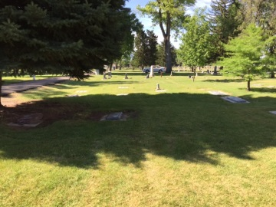

Our mission is to raise funds to construct a monument and individualized plaques to recognize these individuals who have been forgotten and to celebrate their lives.

Today we believe these people have value and deserve the same dignity as all human beings. Many forgotten and lost in life should no longer be lost in death.

“There is something compelling whenever people without a voice are given the chance to speak . . . And if the voiceless people happen to be speaking from the grave-there is no way to ignore the story”- Don Schance Jr. about the Georgia State Hospital Cemetery.

For more information please contact Dallas Earnshaw, Superintendent or Janina Chilton, Historian 801-344-4400

